**Project Start Date: 11-Sep-2018**

**Project Submission Date: 11-Oct-2018**

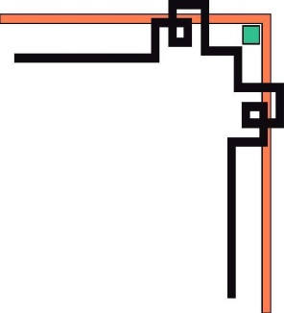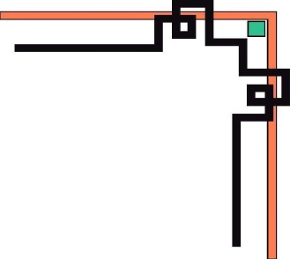

**eProject SEM-3**

**.NET**

**Project: Karnel Travel**

***Group 3:***

Student1058384 HUY DANG TUAN (LT)

Student1007818 SON PHAM NGUYEN HOANG

Student1111738 PHONG TRAN TRUNG

Student989084 NHI NGUYEN THI YEN

***Supervisor:***

MY LINH ONG THI

1. **PROBLEM DEFINITION**

***(Form No. 1/eProjects/PS/Ver1.0)***

* Karnel Travels is a Tours and Travels Company which provides the various transportation facilities between the cities like tourist spots, transportation between different cities in the country, also provides accommodations in hotels, etc.
* Also, they provide the online facility where the customers can visit online, view and order for the tours and as well the transportation. Now they want to provide a website, through which they want to attract the customers. They want to reach out to the customers by providing various information services like the list of tourist spot, information about the various hotels and restaurants, etc.
* They want the website to be a URL Specific. So, they approached us to build a website for them.

***Benefits of building website Karnel Travel***

Website KarnelTravels.net was built to improve the quality of service of the company. The First, the technological advancements these days it allows businesses to manage and maintain the content of the web application and keep track of all the records of client’s interest and bookings in the most effective manner. The Second, Travel & Tourism collaborates with businesses with almost every transport service provider like railway, airways, sea etc. Therefore, for making your travel & tourism website a successful you must collaborate with transport and booking providers for making a good travel & tourism web application for its users. The Third, Travel & Tourism web applications are developed taking all the measures and implementations which make it safer and secure both clients and business owners. Plus, it keeps all the client’s information safe from everyone. Therefore, Travel & Tourism companies should hire a good web application development company for developing a secure website. Finally, A travel & tourism web application should act as a single web application for booking tickets, hotels, sightseeing, car rentals, and sometimes travel related shopping as well. Moreover, for all these, you are not required to create a single portal for each of them. Plus, people these days prefer everything at one place.

1. **CUSTOMER REQUIREMENT SPECIFICATION (CRS)**

***(Form No. 2/eProjects/PS/Ver1.0)***

1. ***Client: Karnel Travel Company***
2. ***Business/Project Objective:***

* The URL should be <http://www.Karneltravelguide.com>
* The website should contain a menu through which the different topics can be fetched out with an ease.
* The menu should contain the following:
  + Home Page
  + About Us
  + Search page
  + Information Page
* Tourist Spots available with in the country.
* Travel Information
* Hotel Information
* Restaurant Information.
* Resorts Information
  + Contact Us
* The About Us Page should include the details about the company, also it should include the details about the facilities that it will provide like transportation, packages, transportation and accommodation facility to tourist locations, etc.
* The Search page should implement the search for the various tourist spots like beaches, monuments, etc. and also it should include the search for the Hotels, Restaurants and resorts based on the location, price, quality, quantity and availability. Also, on this page there should be a link for the advanced search page.
* The information page should contain 5 links as mentioned above and it should display the information about the new hotels restaurants and the resorts information also if there is any package or discounts that the company is providing can also be displayed.
* Tourist spots should include the various tourist locations available with in the country.
* Travel information should include the various transportation facilities available with in the country.
* Similarly, the various hotels, restaurants and resorts that are available with in the country should be displayed for the Hotels, Restaurants, and resorts information.
* The contact us Page is the page where the customer can contact the company for placing an order and this page should also include the feedback, which will collect the feedback from the various users of the website.

***Expected delivery dates***

* Project Start Date: **11-Sep-2018**
* Project Submission **11-Oct-2018**

***Input Provider by Client***

* ***Login Admin***

Input: Username, Password

Output: Authorities

Process: Finding username and password in database

* ***Insert record***

User

About Us

Information of Restaurant

Food of Restaurant

Information of Hotels

Room of Hotels

Location

Tourist spots

Transportation

Trips

Vehicle

Information Contacts of User (When user send information)

Upload File (Image of food, hotel, restaurant, transportation, vehicle)

* ***Update record***

About Us

Information of Restaurant

Food of Restaurant

Information of Hotels

Room of Hotels

Location

Tourist spots

Transportation

Trips

Vehicle

Status Information Contacts of User

Upload File (Image of food, hotel, restaurant, transportation, vehicle)

* ***Delete***

User

About Us

Information of Restaurant

Food of Restaurant

Information of Hotels

Room of Hotels

Location

Tourist spots

Transportation

Trips

Vehicle

Information Contacts of User

IMG (Image of food, hotel, restaurant, transportation, vehicle)

* ***Find***

User

About Us

Information of Restaurant

Food of Restaurant

Information of Hotels

Room of Hotels

Location

Tourist spots

Transportation

Trips

Vehicle

Information Contacts of User

***List of Deliverables***

* ***Document***

Customer Requirement Specification

* DFD
* Process Diagrams (state Diagrams)
* Use case Diagram

Design document

* DB Design / Structure
* Flow Charts
* ER Diagrams
* Data dictionary

User Guide / Installation Guide

Check list

Database (SQL Azure or MS SQL Server)

* ***Website***

Deployment website using windows Azure

Source Code

***Hardware Requirements***

* ***Client:***

HDD: 150G or larger (You can use SDD)

CPU: Intel core i3 or higher

Network: Card or WIFI

RAM: 2G or higher

* ***Server***

HDD: 1TB or larger

CPU: Intel core i7/AMD: 2.6 GHz or higher

RAM: 4G or larger

***Software Requirements***

* ***Client:***

OS: Win 7/ Win 8/ Win 10

Browser: Firefox/Chrome/Opera

* ***Server:***

OS: Win2K8, Win2K12, Win2K16, Ubuntu Server, VPS, Azure…

Browser: Firefox/Chrome/Opera

MS SQL Server 2012 (or higher) /SQL Azure

.NET Framework 3.5

MS Visual Studio 2017 Professional (using Entity Framework)

***Scope of the Word (in Brief)***

Reviews Service of Karnel Travel such as: hotels, rooms, food, vehicles, … Before, you create planning of vacation.

1. **Architecture & Design of System**

***(Form No. 3/eProjects/PS/Ver1.0)***

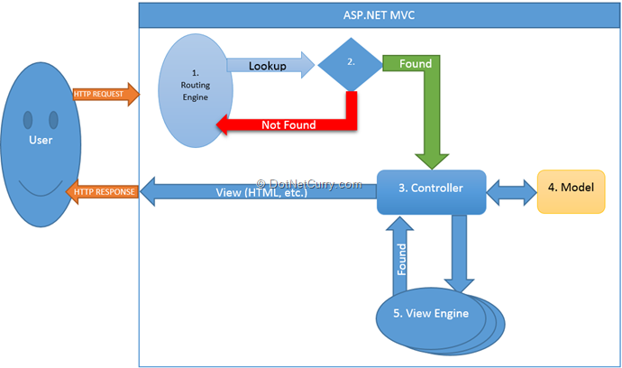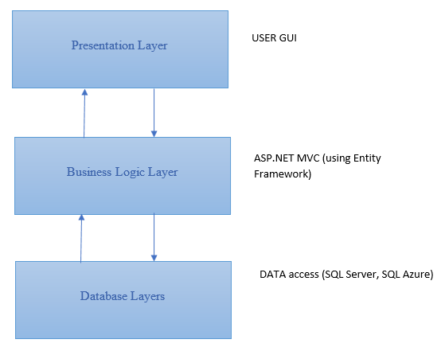***Web-Based Distributed 3-Layer Architecture of the Project***

***Using MVC in Project***

1. **Data Flow Diagrams (DFD)**

***(Form No. 5/eProjects/PS/Ver1.0)***

1. **Flow Charts**

***(Form No. 6/eProjects/PS/Ver1.0)***

1. **Process Diagrams**

***(Form No. 7/eProjects/PS/Ver1.0)***

1. **Entity Relationship Diagrams**

***(Form No. 8/eProjects/PS/Ver1.0)***

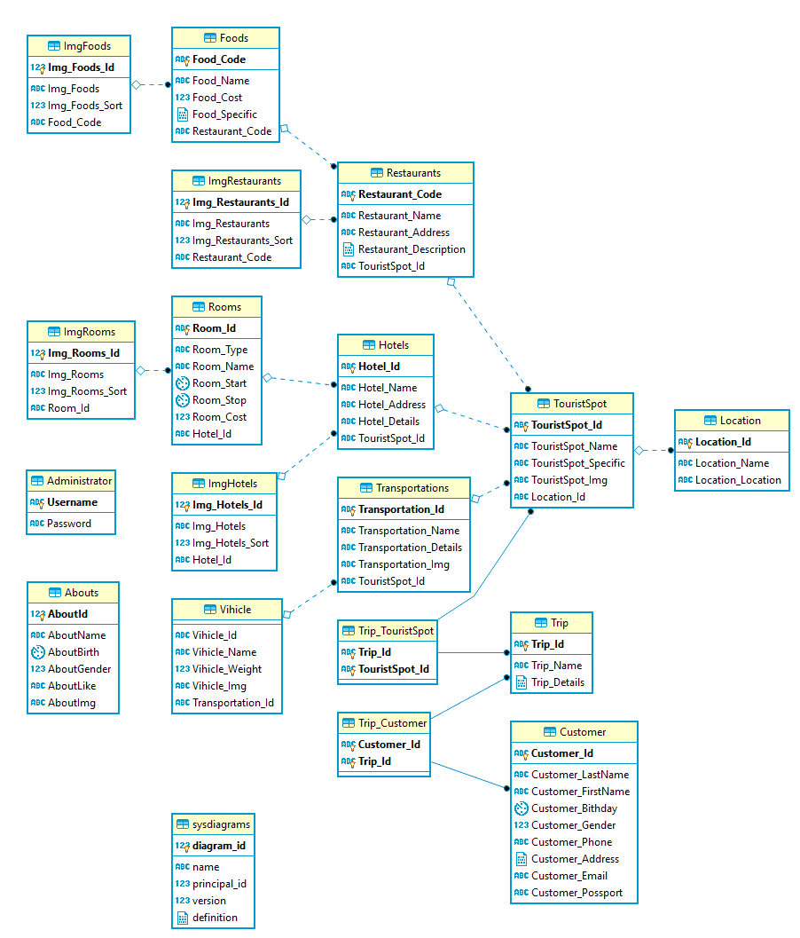

1. **Data modeling (SQL SERVER)**

***(Form No. 9/eProjects/PS/Ver1.0)***

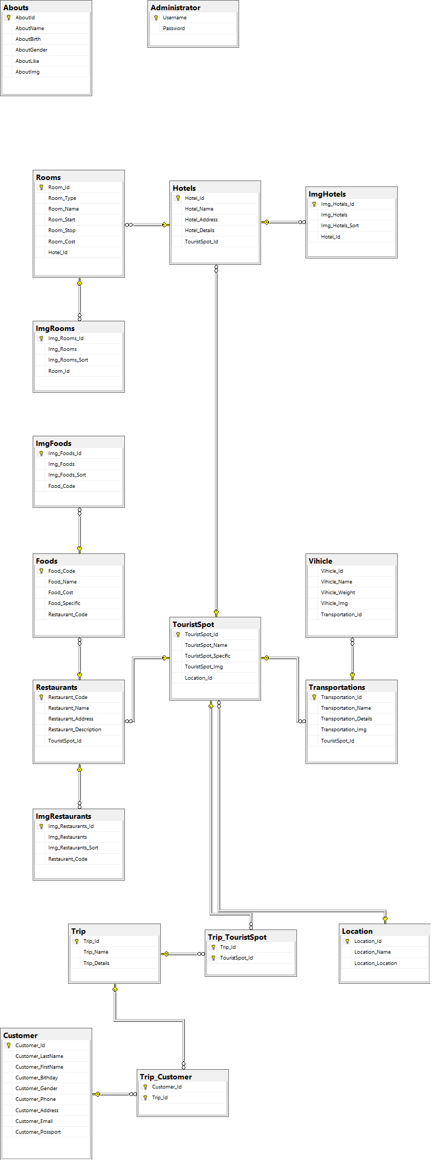

1. **Data Dictionary**

***(Form No. 10/eProjects/PS/Ver1.0)***

1. **Site Map**

***(Form No. 11/eProjects/PS/Ver1.0)***

1. **Task Sheet**

***(Form No. 12/eProjects/PS/Ver1.0)***

1. **Check list Validation**

***(Form No. 13/eProjects/PS/Ver1.0)***

1. **User GUI**

***(Form No. 14/eProjects/PS/Ver1.0)***